**Тренировочный вариант КИМ ОГЭ по физике**

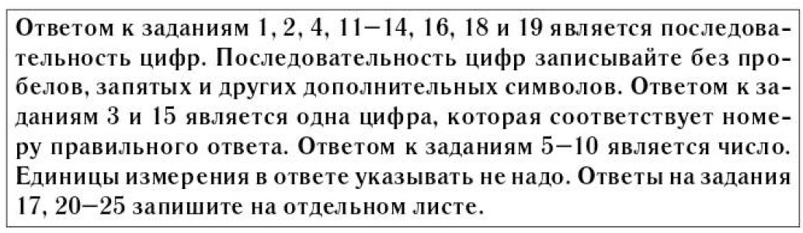

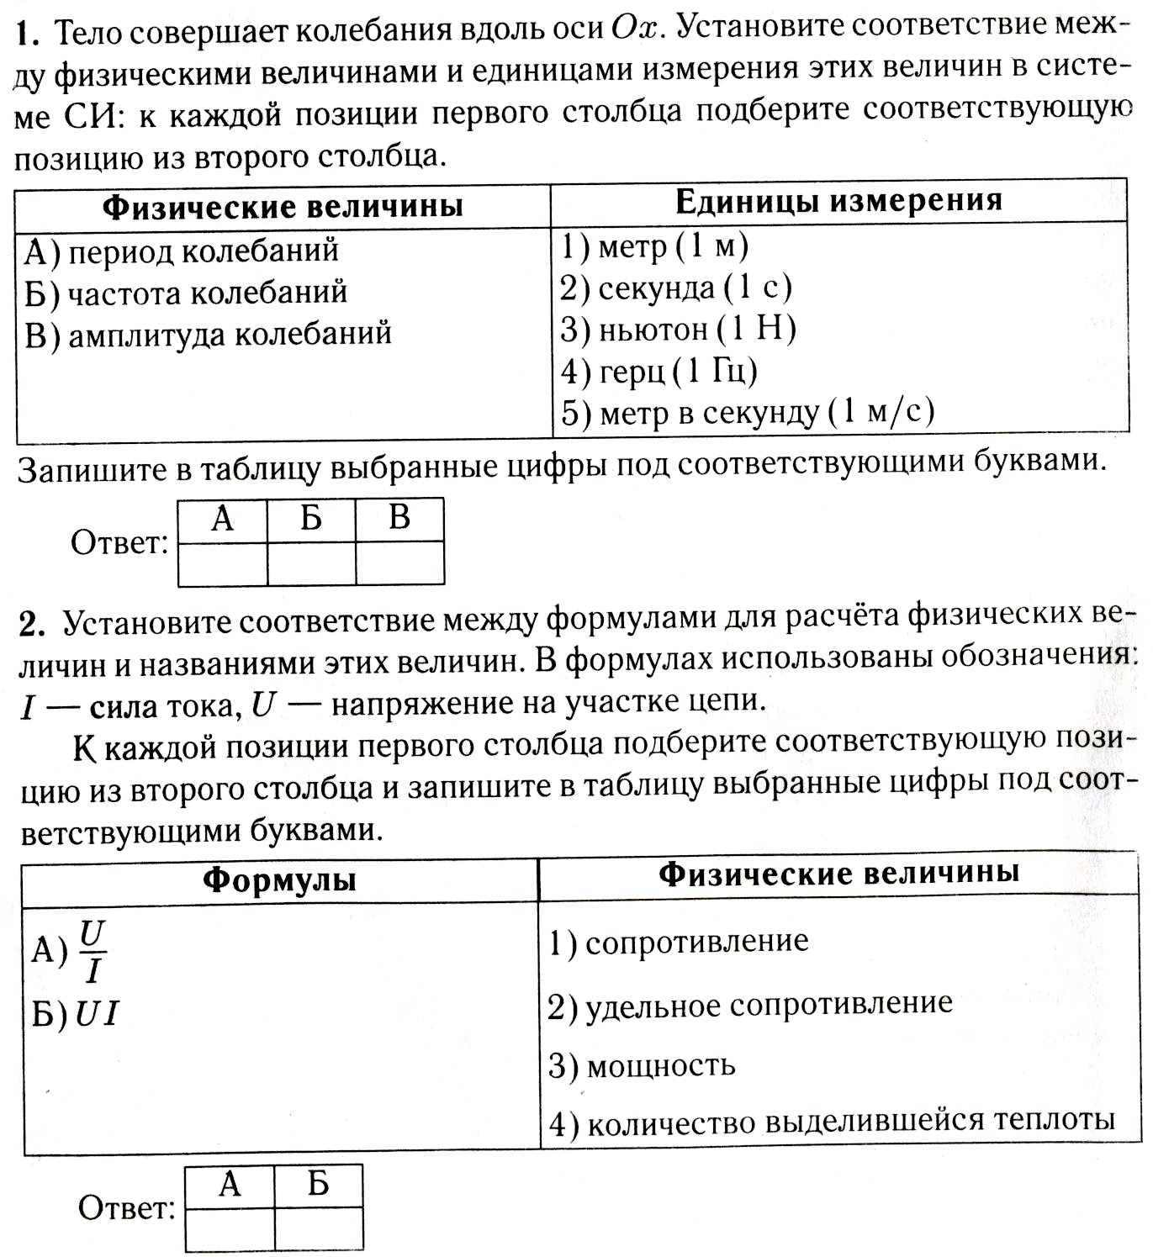

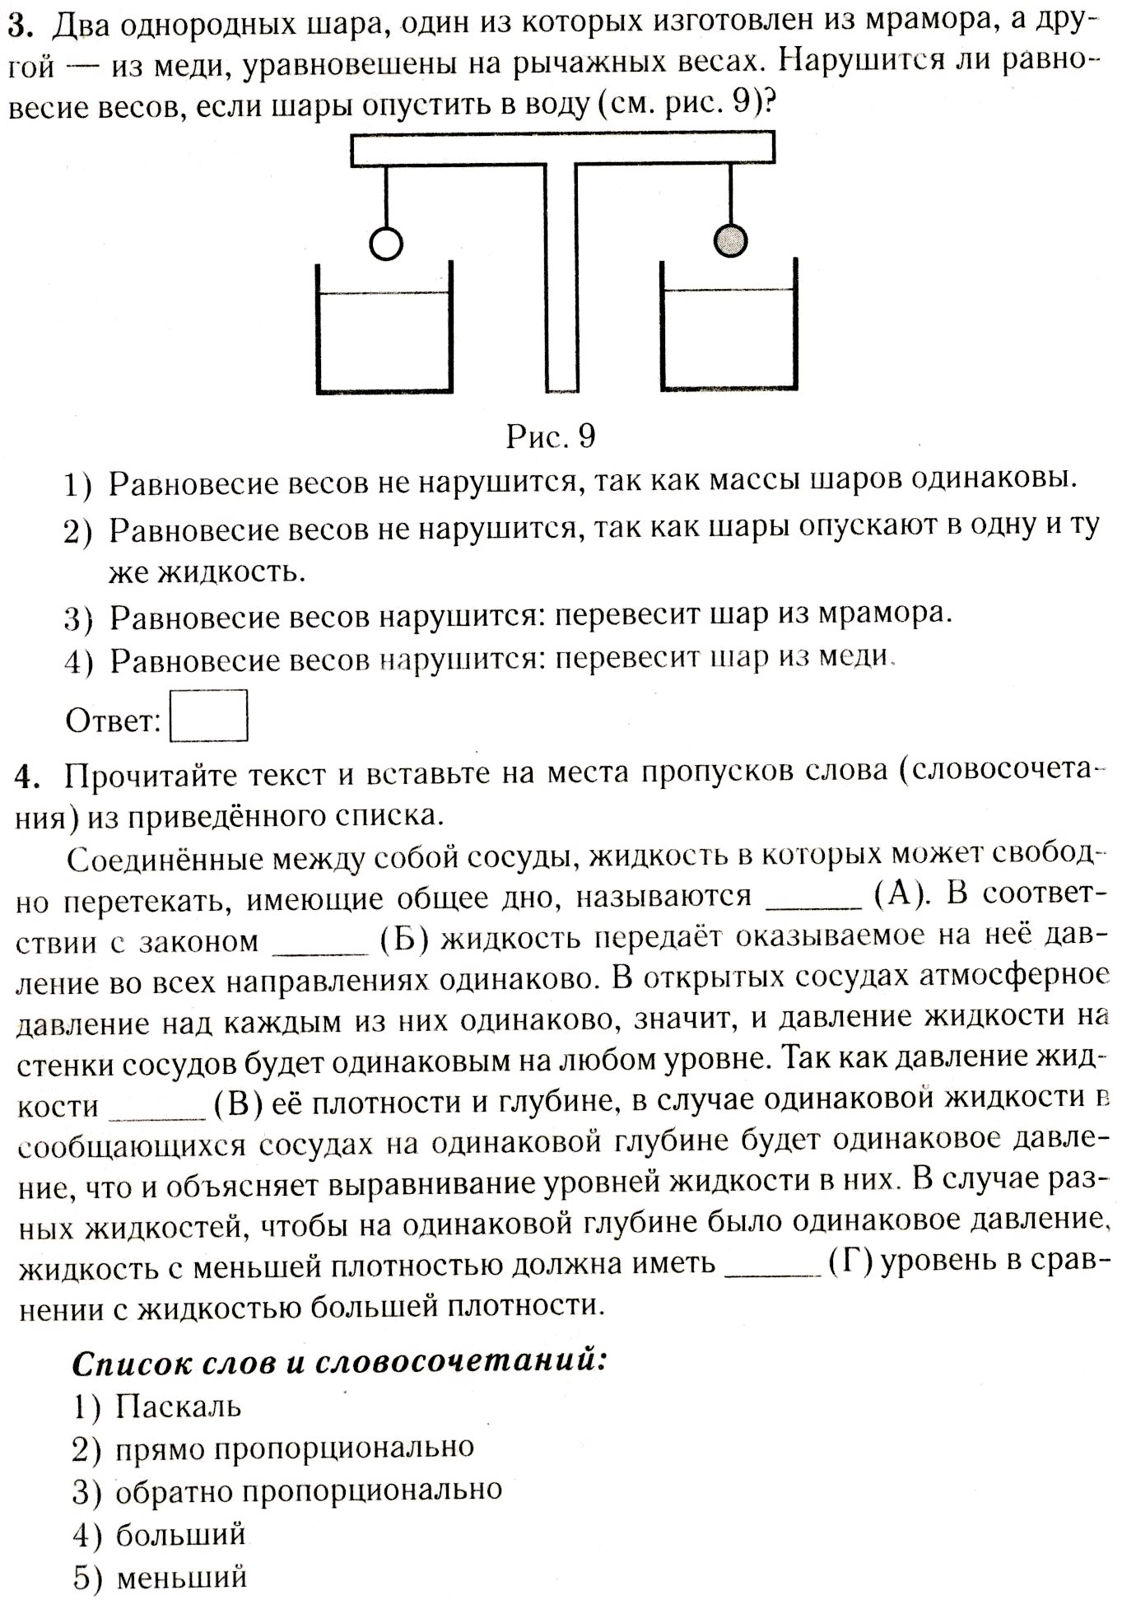

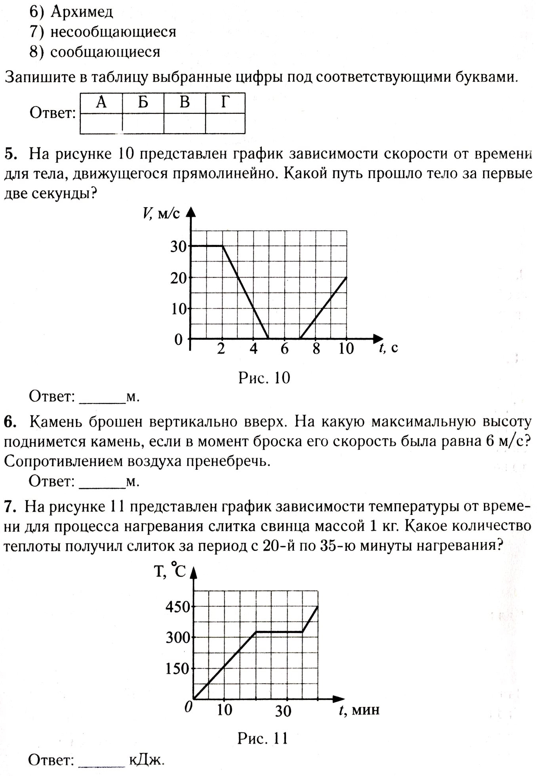

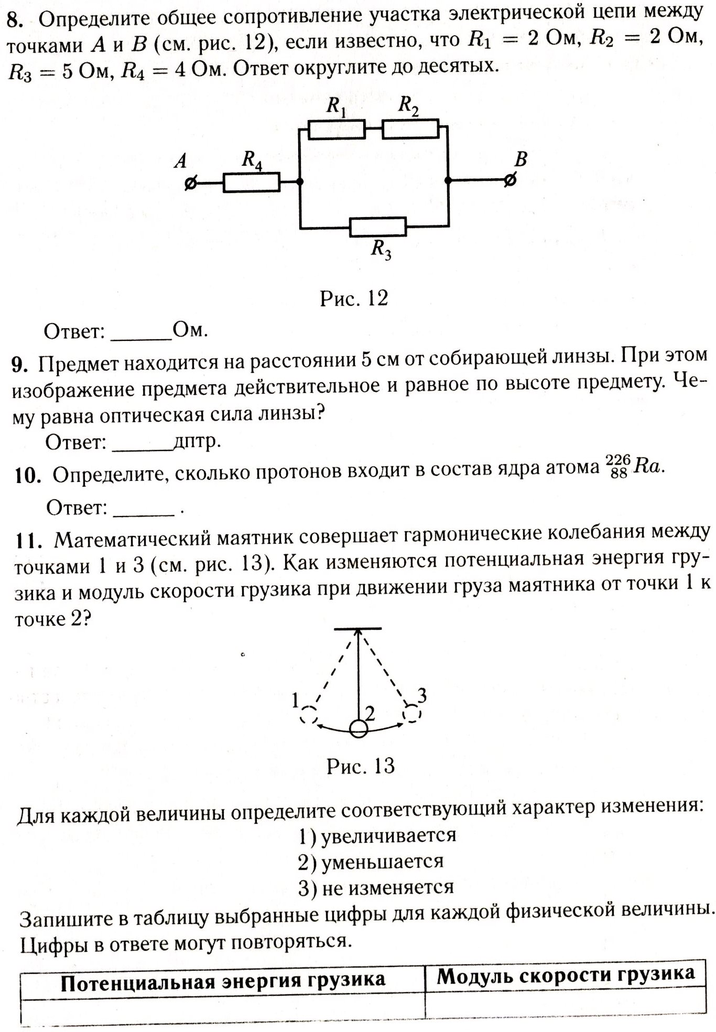

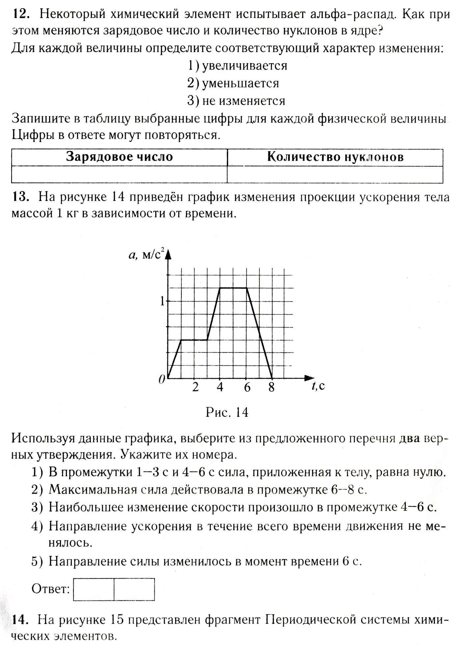

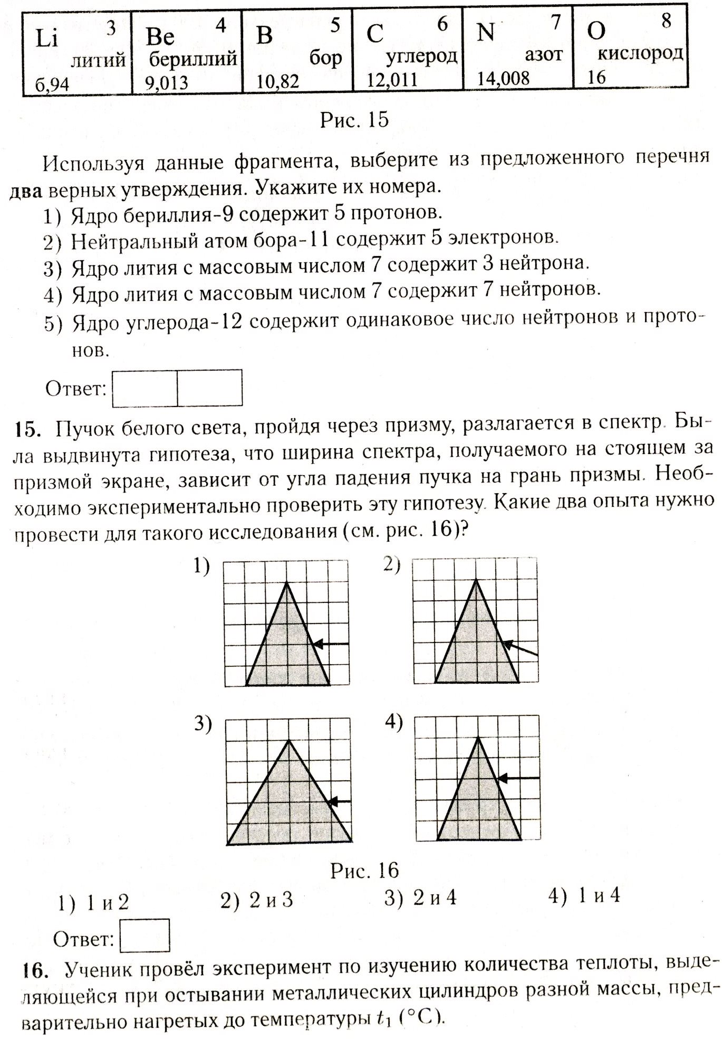

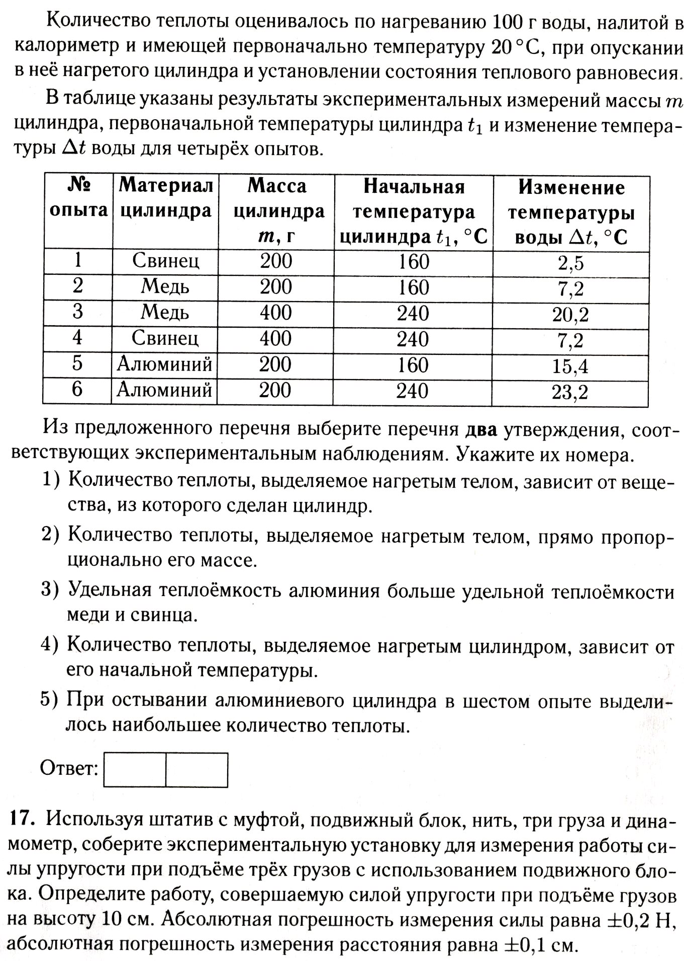

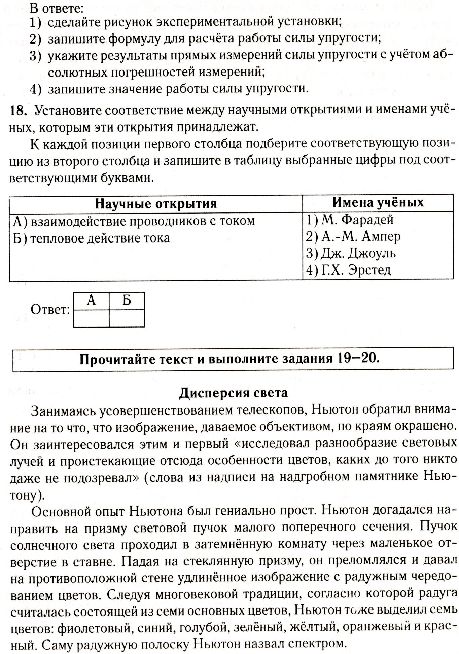

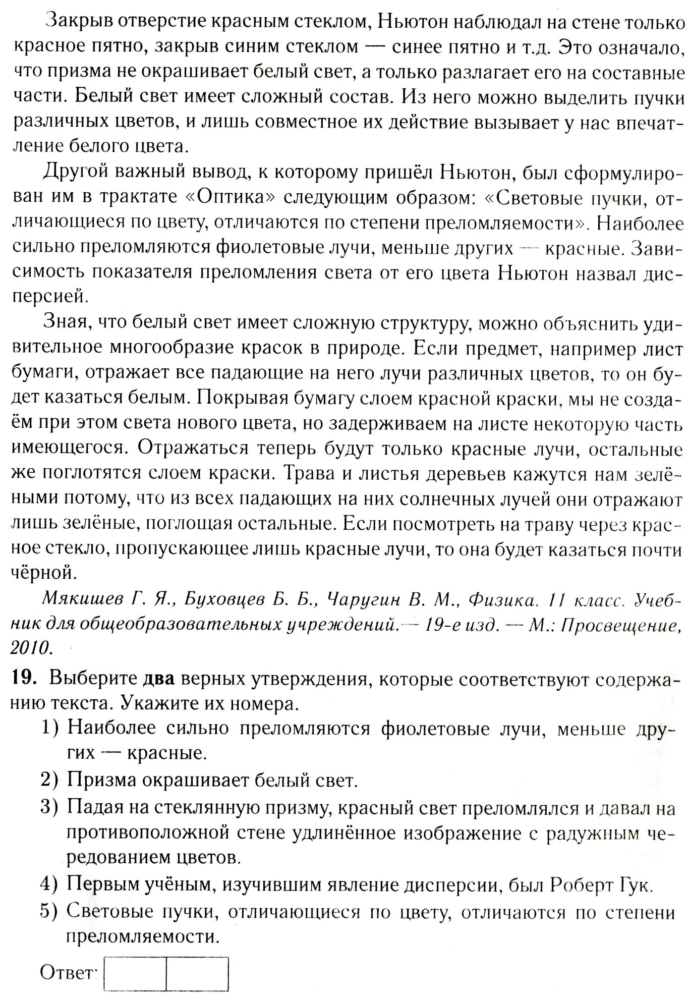

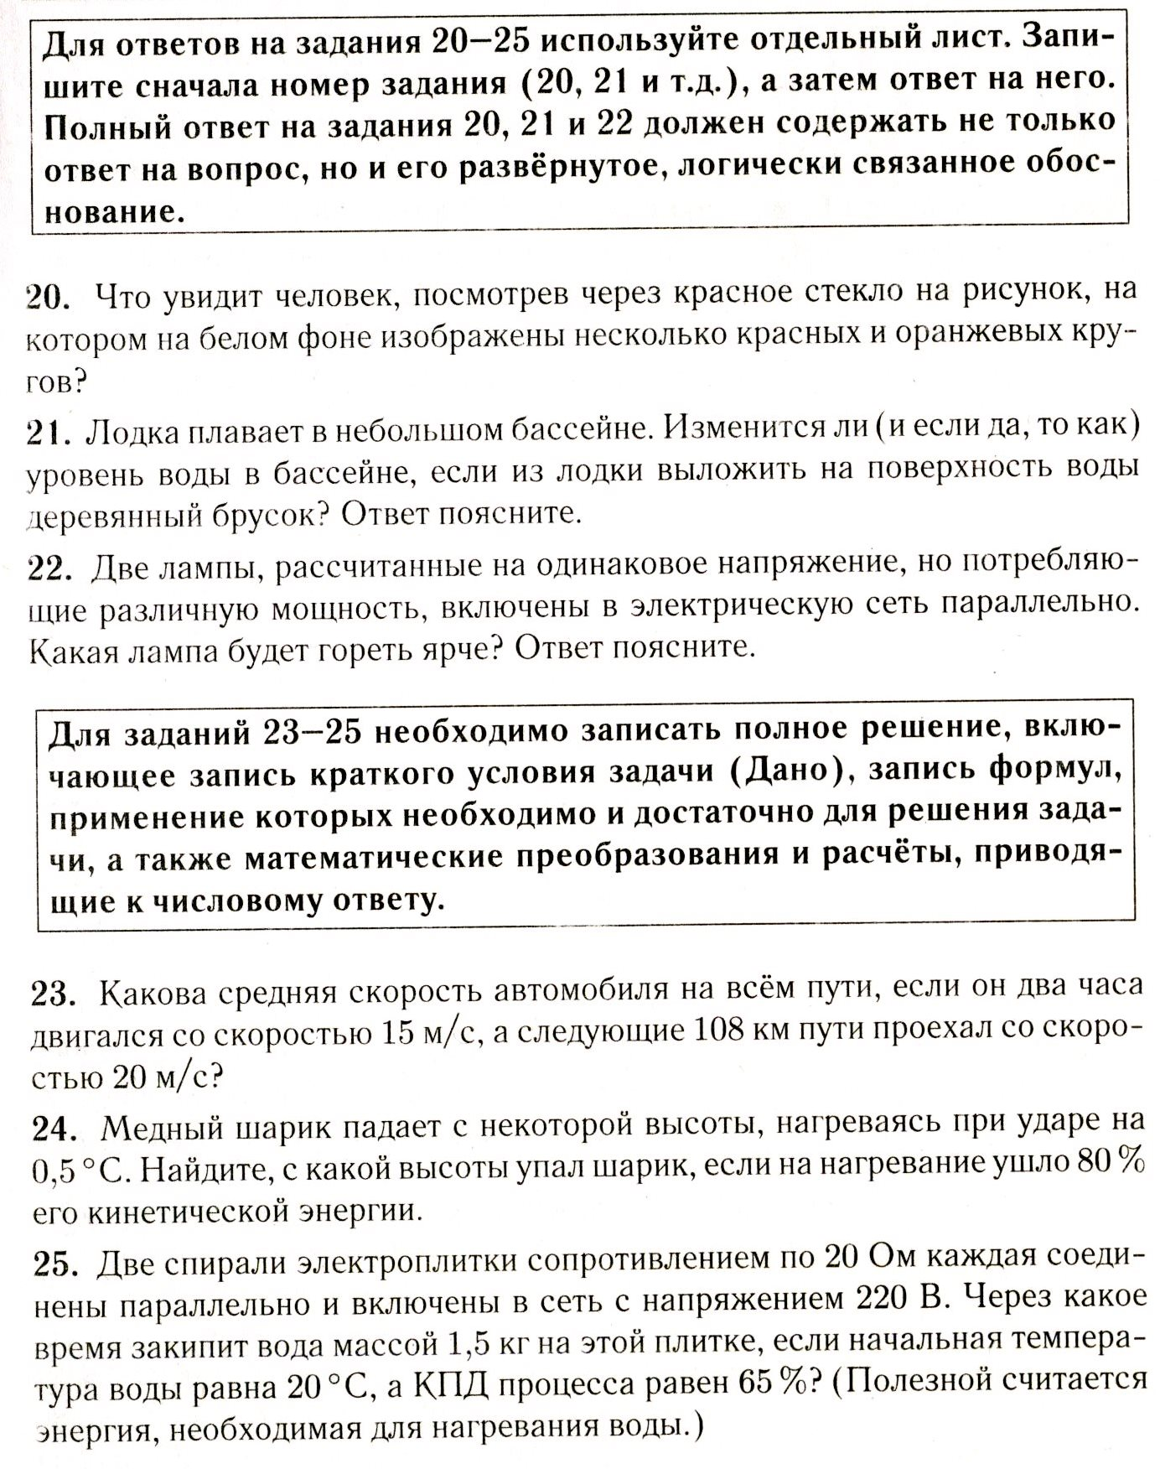

**Ответы и решения**

|  |  |  |  |  |  |  |  |  |  |
| --- | --- | --- | --- | --- | --- | --- | --- | --- | --- |
| **№** | **1** | **2** | **3** | **4** | **5** | **6** | **7** | **8** | **9** |
| Отв. | 241 | 13 | 4 | 8124 | 60 | 1,8 | 25 | 6,2 | 40 |

|  |  |  |  |  |  |  |  |  |  |
| --- | --- | --- | --- | --- | --- | --- | --- | --- | --- |
| **№** | **10** | **11** | **12** | **13** | **14** | **15** | **16** | **18** | **19** |
| Отв. | 88 | 21 | 22 | 34 | 25 | 1 | 145 | 23 | 15 |

